2019 Review of the GARI Database

Invitation to submit comments or suggest changes to the Global Accessibility Reporting Initiative (GARI)

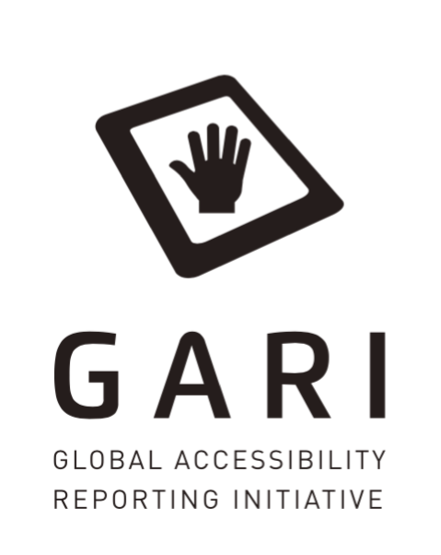

Background

The Global Accessibility Reporting Initiative (GARI) is a project created in 2008 by the Mobile & Wireless Forum (MWF) and designed to help consumers learn more about the various accessibility features of wireless devices and to help them identify a device that best suits their needs.

To date, the project website (www.gari.info) includes information on

- 121 features for mobile phones,
- 67 features for tablets,
- 61 features for smart TVs and
- 52 features for wearables.

These features have been developed in collaboration with the disability community, accessibility experts, industry and national regulators.

As part of the GARI project, the MWF has committed to regular reviews of the features that we report on in light of changes in the technology and customer needs. As a result, we invite all stakeholders to provide any comments or suggestions on the features that they would like to see reported on by manufacturers, as well as comments on the usability of the GARI website.

For this 5th review cycle, comments or suggestions can be made until 31 July 2019.

Guidance for commentary

Since GARI was designed to consolidate all reporting requirements that existed at the time for manufacturers (and still may continue to exist), some features in the database are a result of regulatory requirements. Consequently, some features, like whether a device supports SMS, might appear redundant since all phones support this feature, however, as it continues to be a reporting requirement in one country, we must retain this feature for compliance purposes. Therefore, while we welcome comments on all existing features, it should be understood that manufacturers may not be able to amend or remove particular features for the reasons stated above. That said, commentary about the continued usefulness of particular features in view of market conditions, is definitely welcome.

When providing suggestions for new features, we encourage you to provide these in a way that manufacturers can objectively determine whether their device supports that given feature or not. Features such as ‘Does the device have large keys’, for example, would invite a subjective response, and may not ultimately be useful. Likewise, suggestions should be based on the features and software that the device is shipped with, rather than what might be added to the device later, such as third party software, device or applications – unless support for certain devices (e.g. braille displays) is built into the operating system shipped with the device.

Lastly, we ask you to remember that the GARI project is a global project, and as such, we are not able to include a reference to whether a device supports access to a particular service where that service is only available in a particular location or country (e.g. relay services). If possible express the suggested feature in a way that may be applicable in different countries. Likewise, we are not able to include pricing, carrier availability or broadcaster information.

Suggestions for new features

Mobile wireless technology continues to evolve at an incredible pace, with many of developments having the potential to significantly enhance the accessibility of a device. We would welcome comments or suggestions that you have in relation to any new features that we should consider adding.

If possible, please provide feature suggestions in the following format:

Table 1 with newly proposed features for GARI
Device  & Category:  (e.g Hardware, Hearing, Vision, Dexterity, Cognition) | Proposed Feature | Proposed Description | Type of Response | Technical Note or Reference*
Mobile phone, General | Device Coupling – USB** | Allows customised devices to work with the phone. Device can be connected to the phone by using a USB connection. | Yes / No
Mobile phone, Vision | Headset/Headphone - plug connected  - This is an existing feature. The proposal is to add reference to ‘Headphone’ | You can plug in a headset containing headphones and a microphone, or just a headphone. This allows you to answer calls, listen, and talk without holding the phone. This can mean better call quality for some people and is useful if you have trouble holding a phone. | Yes / No
Mobile phone, Tablet, Wearable, Smart TV, Vision / Cognition | Text-to-Speech** (TTS) | The device has built-in Text-to-speech (TTS) technology that reads out the digital text on the device. | Yes / No
Mobile phone,  General | FM Radio** | The device is equipped with an active FM chip, enabling handset owners to listen to their local radio stations. This is particular helpful in times when the internet might be down. | Yes / No
Mobile phone,  General | Biometric Login** | The device can be unlocked without entering a PIN code but using instead one of the following biometric methods: fingerprint, facial, voice or iris recognition. | Yes / No
Mobile phone, tablet,  Dexterity | Physical keyboard** | The device has a built-in physical keyboard. | Yes / No
Mobile phone, Vision / Dexterity | Near Field Communications (NFC)** | Near Field Communication (NFC) technology enables wireless communication between two electronic devices that are close to each other and it is often used in mobile payment systems. | Yes / No
Smart TV,  Hearing | Supports Closed Captioning for Broadcast | Device is capable of displaying closed captioning that is included in a broadcast. | Yes / No
Please insert Your proposed new features below: |  |  | Answers should generally be capable of being answered: Yes / No

*The ‘Technical Note or Reference‘ column is meant for the guidance of those completing the forms and is not part of the published information. It might refer to a standard or other technical reference that will assist manufacturers in determining the correct response.
** This is one of the 26 Features used by Wireless RERC in their Mobile Phone Accessibility Review, which also fed into the FCC’s 2018 CVAA Biennial Report on the implementation of the CVAA.

Comments on existing features

To provide comments on the currently listed features in GARI, please consult the following pages and click on the button “All”:

- Mobile Phones: GARI Mobile Phone Section
- Tablets: GARI Tablet Section (click on tablets on the top of the page)
- Smart TVs: GARI Smart TV Section
- Wearables: GARI Wearables Section

Applications

Accessibility related or assistive applications can add considerable functionality and usefulness to a device and in order to help consumers understand how a device’s accessibility may be further enhanced, the MWF has added an app section. Apps can be searched for by name, by impairment category or by finding a device and then viewing the supported apps from those listed.

We contact each app developer individually to request permission to list their app although app developers can list their own apps directly (for free) on GARI. If there are particular assistive or accessibility related apps that you believe we should have on GARI please let us know and we will endeavour to add these.

Please suggest apps in any of the 18 GARI languages: English, Arab, Danish, German, Spanish, Finnish, French, Hungarian, Italian, Korean, Dutch, Norwegian, Polish, Portuguese, Romanian, Swedish, Japanese, Chinese.

Name of App | Link to app store or developer’s site
(fill in name of the app) | (fill in link to the app store)

Future GARI participants

Today, 25 companies are participating in the GARI project and displaying their devices in the database to inform users about their accessibility features. Do you know a company that is not part of GARI yet but who you would like to see displaying their products on the database? Please let us know their name and we will get in touch with them.

Company (product) | Contact person

Spreading the word

We often hear from our supporters that many users who could really benefit from the information in GARI, do not know yet about the database. Do you know organisations or networks that should know more about device accessibility and who we should contact to inform them about the GARI project?

Organisation/Network | Contact person

Submission of comments

The MWF welcomes any comments that you have on GARI and all inputs can be emailed to michael.milligan@mwfai.org or sabine.lobnig@mwfai.org by 30 June 2019. Please also visit the GARI blog to follow our progress on this review.

We thank you in advance and are looking forward to your input!

Michael Milligan
Secretary General
Mobile & Wireless Forum (MWF)

